**Static Website Hosting on AWS**

**Objective**

The objective of this project is to host a simple static website on **Amazon Web Services (AWS)** using **Amazon S3**. The website displays a greeting message, a profile icon, and personal information (name and email). This project demonstrates how AWS S3 can be used to host and serve static web content in a cost-effective, highly available, and scalable manner.

**Key Concepts**

**1. Amazon S3 (Simple Storage Service)**A highly scalable and durable object storage service that allows hosting of static websites by enabling public access to HTML, CSS, JavaScript, and image files.

**2. Bucket Policy for Public Access**A JSON-based access control configuration that allows anonymous users to retrieve objects from the S3 bucket.

**3. Static Website Hosting Feature**A built-in S3 feature that makes a bucket behave like a web server by providing an endpoint to serve static content.

**Implementation Overview:**

The static website was developed using standard web technologies (HTML, CSS) and hosted on an AWS S3 bucket configured with static hosting settings. The steps involved creating the website files, setting up the bucket, uploading the content, and enabling public access with proper policy configuration.

* **Screenshots :**

1. Hosted Website Screenshot

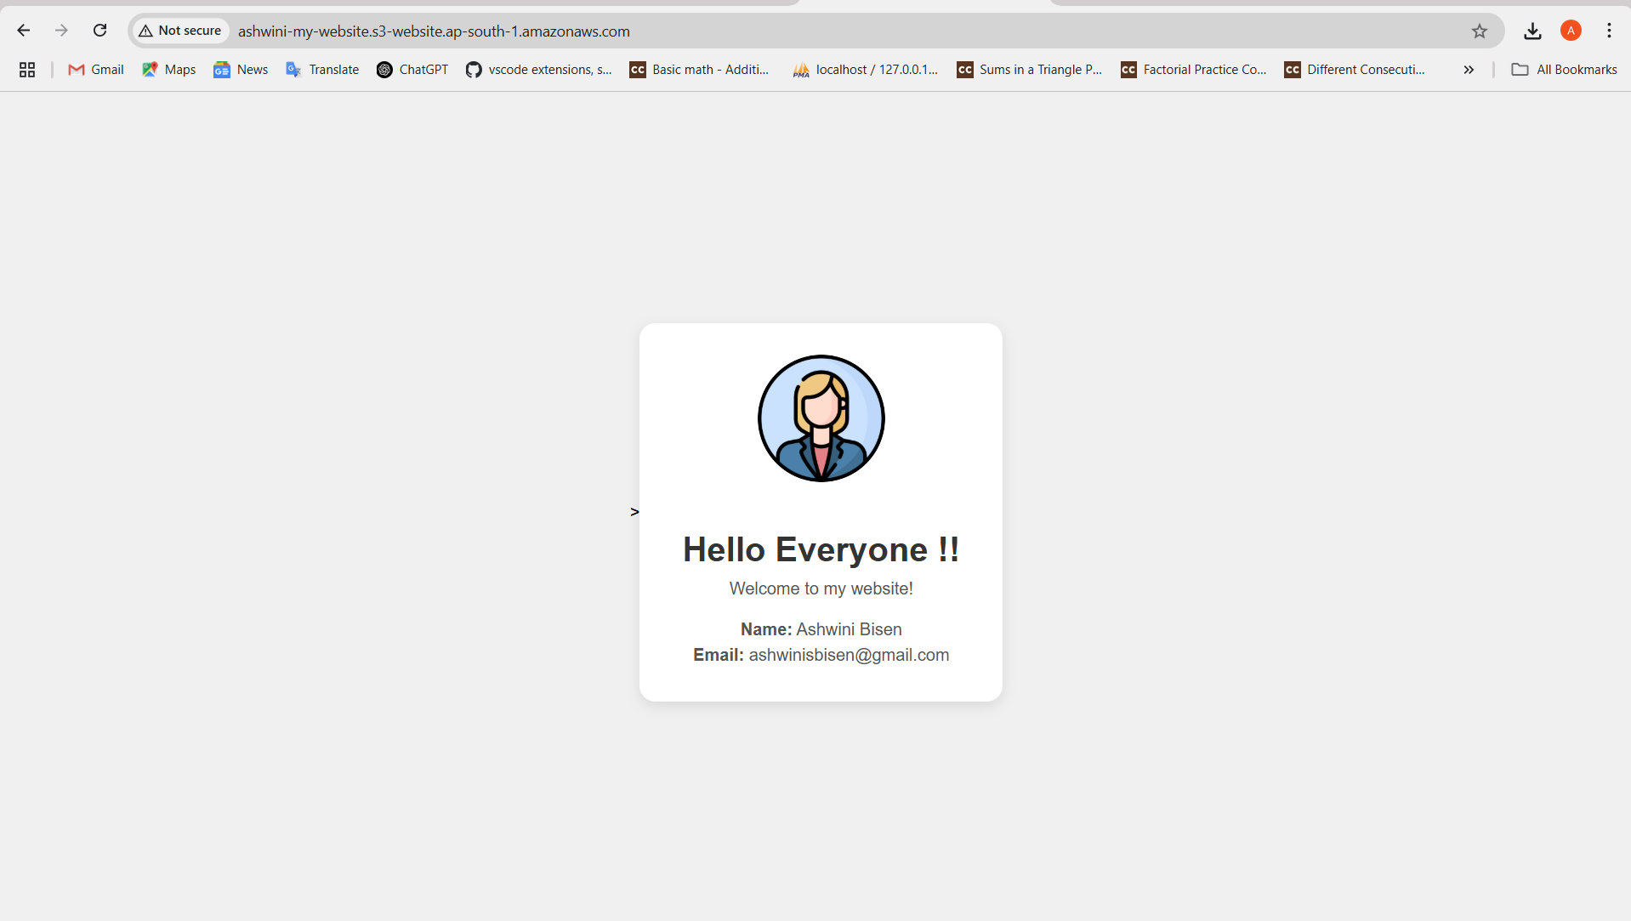

1. Static Website Hosting Settings

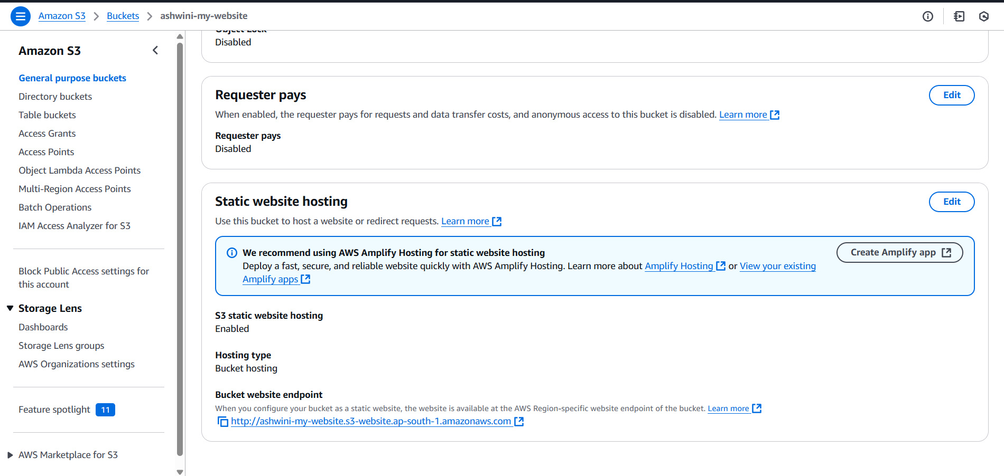

1. Bucket Policy Editor View

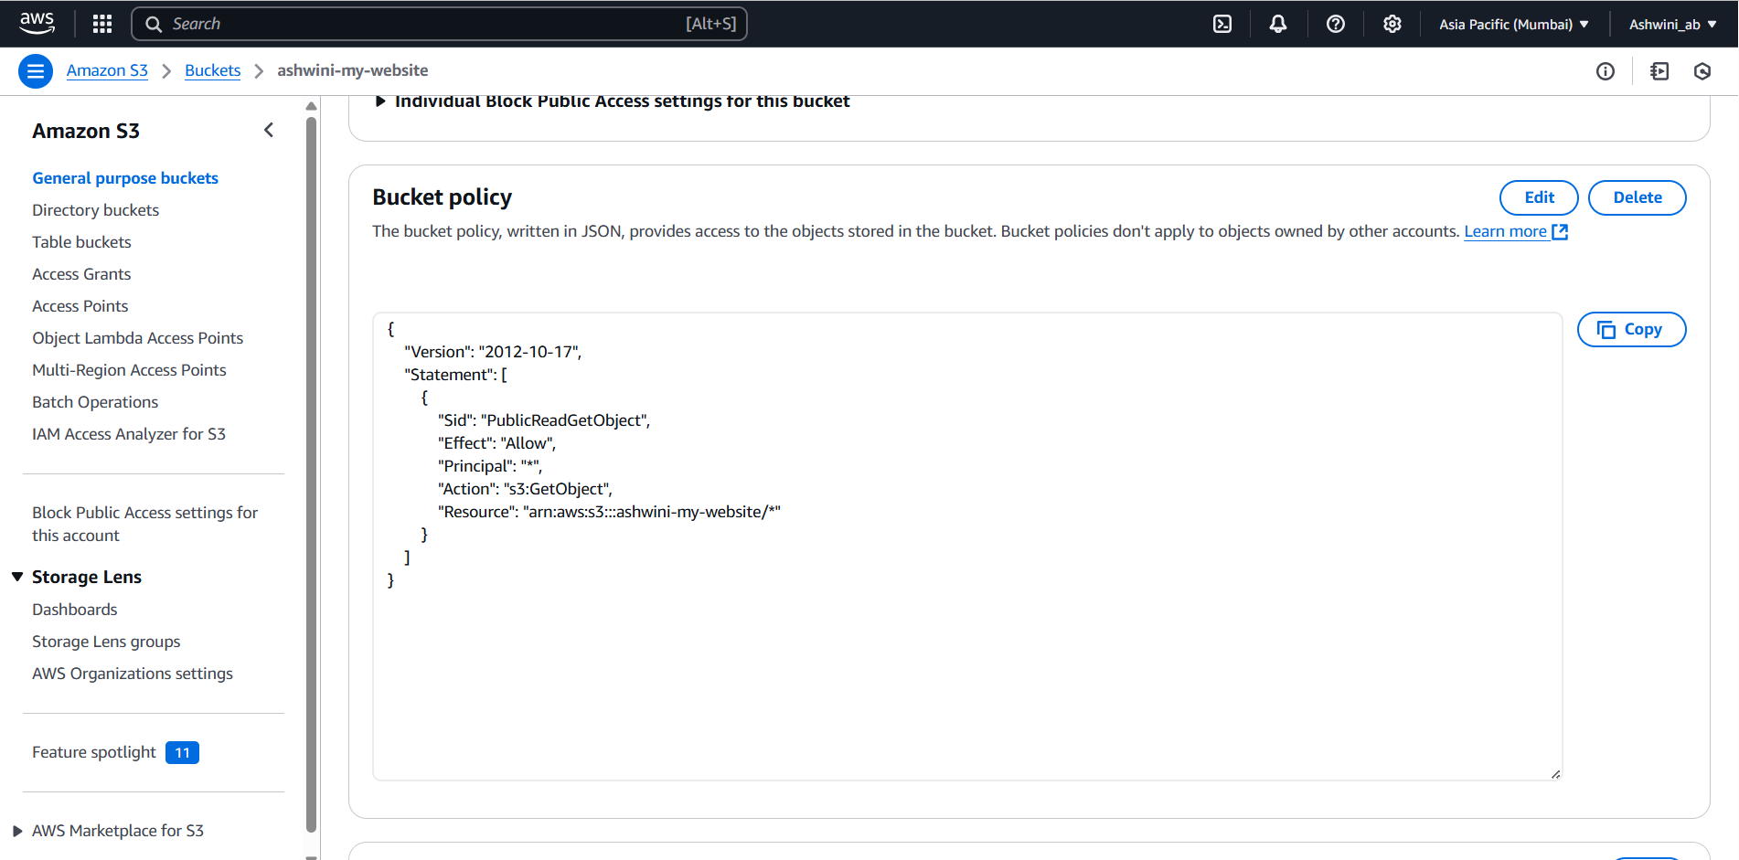

1. Bucket Details

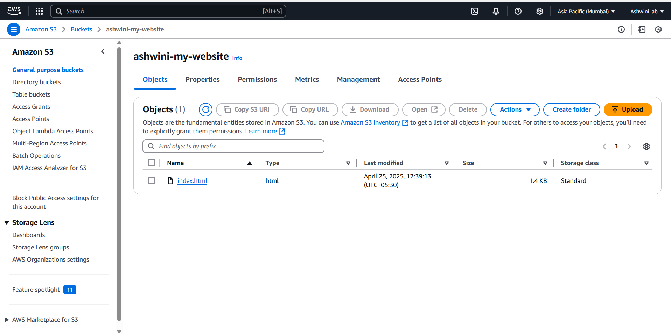

* **Live URL:**

http://ashwini-my-website.s3-website-<region>.amazonaws.com

**Conclusion :**

This project demonstrates a successful deployment of a static website using AWS S3, highlighting its simplicity, cost-effectiveness, and scalability. The site is now live, publicly accessible, and can be enhanced further with advanced AWS services.